**Connectivity of a randomly deployed 1-D ad hoc network.**

## Objective

To analyze the probability of connectivity of a randomly deployed 1-dimensional ad hoc network.

In the first part of the experiment, we analyze connectivity for a simple 2-node network. In the advanced section, we extend this analysis to nodes.[1]

## Preliminaries

An important feature of wireless networks is that the node locations in a network are random, because of either mobility or deployment constraints. Thus, in exploring the fundamental performance limits of wireless networks, it is reasonable to model the node locations as random variables.

A *network graph* captures the communication capabilities among the nodes in the network and connectivity is an important network graph property. For a wireless network, the network graph also captures the communication constraints; for example, it can be used to specify the nodes that are in communication range of any node.

We assume that a transmission from node , located at , can be decoded at node, located at , if the Euclidean distance between and is less than i.e., in 1-D , or , in 2-D.

## Mathematical analysis of a 2-node 1-D network

Consider a two-node, one-dimensional network with the location of each node uniformly distributed in and chosen independently of each other. Let the transmission range of both nodes be . We now obtain the probability that the two nodes are connected. Without loss of generality, let be the location of the left node and that of the right node; that is, . The two-node network is connected if . This is graphically shown in Figure 9.2. The set of values that can take is denoted by the area OAB. The set of that would result in a connected network is given by the shaded area S in the figure.

Figure 1: S represents the feasible region of a random, connected 2-node, 1-dimensional ad hoc

network.

S is the region satisfying (by definition of and ) and (the connectivity requirement). Since the nodes are distributed uniformly in the probability that the network is connected is the ratio of the area of S to the area of OAB. The area of S isand that of OAB is . Thus, the probability that the network is connected is

where, is the network connectivity fraction or the probability of network connectivity, and

is the normalized transmission range

## Modelling the transmission range

NetSim supports are wide range of pathloss models. In this experiment, we need to use a pathloss model whereby the transmission range of a node is This can be modelled using the *Range based pathloss* model. In this model, the propagation loss depends only on the distance (range) between transmitter and receiver. There is a single *Range* attribute that determines the path loss. Receivers located at or within ‘Range’ see a 0 dB pathloss. Hence received power equals transmit power. Receivers beyond ‘Range’ see a 1000 dB pathloss. Hence received power will be close to -1000 dBm which is essentially zero in linear units.

## Procedure to simulate this scenario in NetSim

1. In NetSim home window click on MANET section. Under the Total Grid settings, set Grid Length as 1000 and under device placement strategy select Manually via Click and Drop.

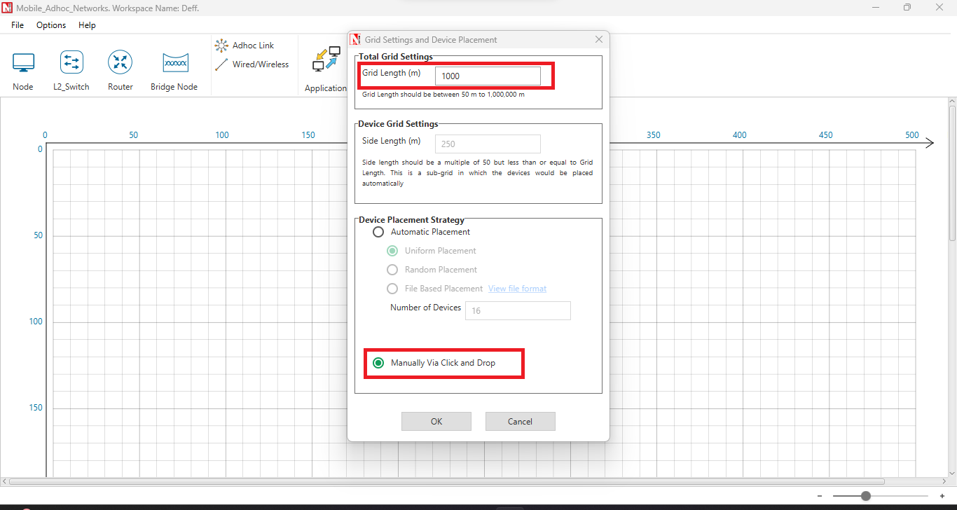

1. Deploy two wireless nodes and establish two ad hoc link connecting both Wireless nodes to ad hoc link. Set the mobility of both devices to NO_MOBILITY, and position both wireless nodes at Y coordinate 500. The X coordinate can be any value at this stage. Since the X coordinate is a variable for this experiment, the exact setting is explained subsequently.

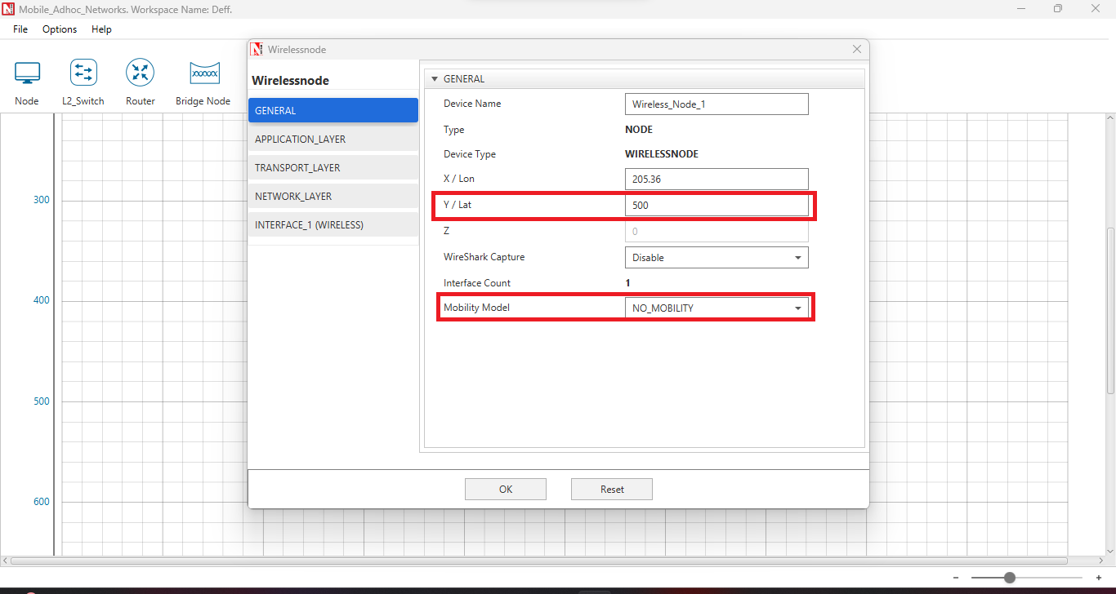

1. Configure an application to communicate between the wireless nodes. Set Channel Characteristics as PATHLOSS_ONLY and Path Loss Model as RANGE-BASED. The range(m) can be any value currently. This is another variable in this experiment and the exact settings are explained subsequently.

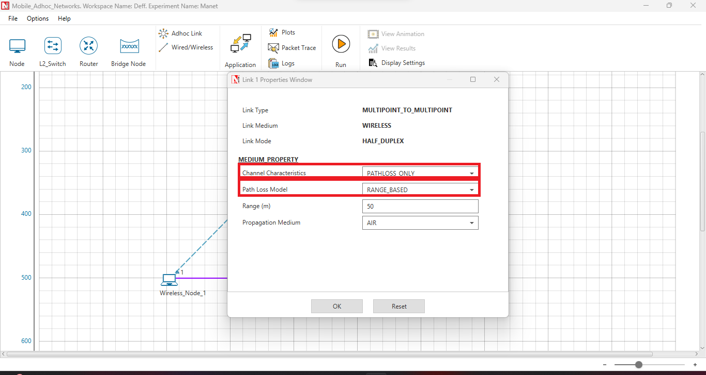

1. Add Static Route from Wireless Node 1 to Wireless Node 2.

* In Wireless_Node_1 properties, go to NETWORK_LAYER and make Static_IP Route enable, then click on Configure_Static_Route_IP.

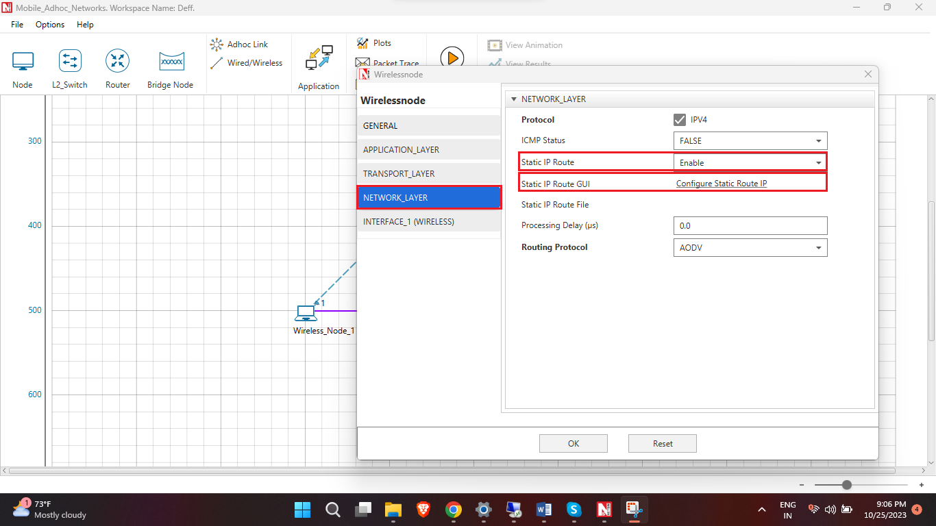

* In the Static IP Routing Configuration Window, add destination ip address (enable Device IP in Display Settings), gateway, subnet mask, metrics, interface id.

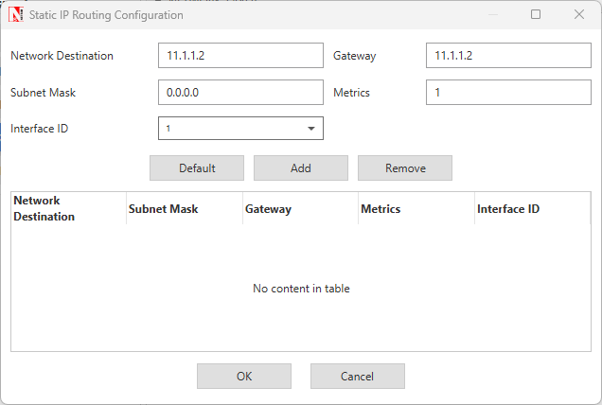

1. Save this scenario and open the Configuration.netsim file in the file explorer.

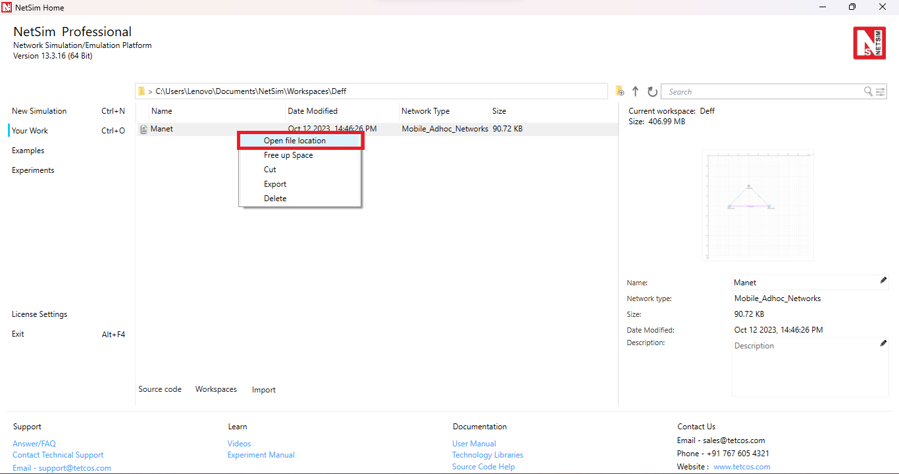

1. Within the POS_3D tag of both wireless nodes, replace the current X coordinates with a variable {n}, where n = 0, 1, 2, 3, and so on, representing an input variable from the multi-parameter sweeper. Similar procedure is repeated for pathloss Range.

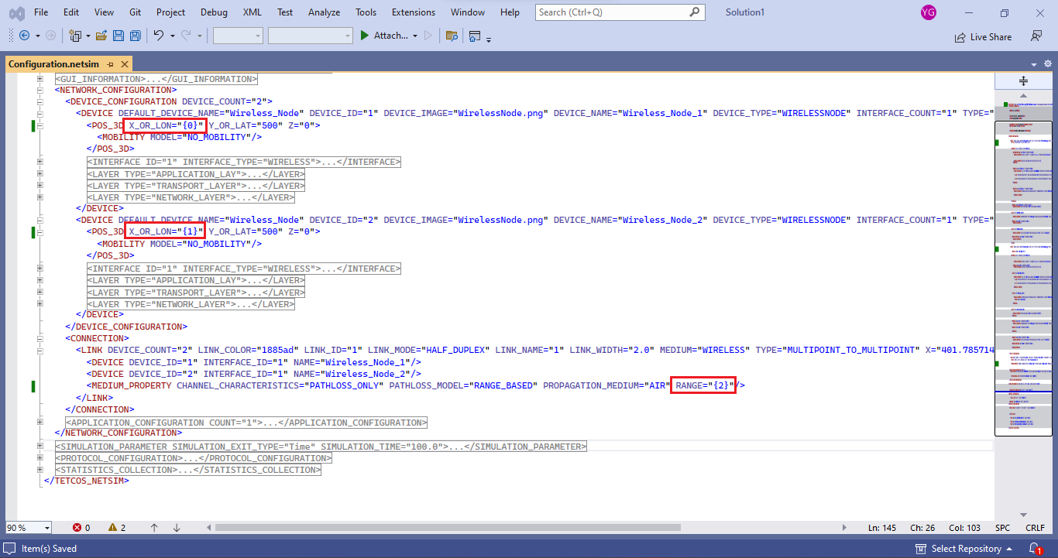

1. Save the configuration file and rename it as input.xml.
2. Download the multi-parameter sweeper from the given link and paste input.xml and the static route text files in that folder.
3. Open the multi-parameter-sweeper.m file in MATLAB and run.
4. The multi-parameter sweeper will execute simulations for various distances (between two nodes by varying the X-coordinate) and pathloss ranges.

## Simulation Results

Use the result.csv file to get the successful transmission probability table and its plot. In this table the fraction of times the network is connected (in simulation) is the probability of network connectivity.

|  |  |  |  |  |
| --- | --- | --- | --- | --- |
| **Transmission Range [m]** | **Normalized transmission range where [m]** | **Count of times network is connected (Total of 100 runs)** | **Network connectivity fraction (simulation)** | **Probability of network connectivity**  **(analysis)** |
| 50 | 0.05 | 10 | 0.100 | 0.097 |
| 100 | 0.10 | 14 | 0.140 | 0.190 |
| 150 | 0.15 | 25 | 0.250 | 0.277 |
| 200 | 0.20 | 33 | 0.330 | 0.360 |
| 250 | 0.25 | 42 | 0.420 | 0.437 |
| 300 | 0.30 | 49 | 0.490 | 0.510 |
| 350 | 0.35 | 50 | 0.500 | 0.577 |
| 400 | 0.40 | 57 | 0.570 | 0.640 |
| 450 | 0.45 | 63 | 0.630 | 0.697 |
| 500 | 0.50 | 69 | 0.690 | 0.750 |
| 550 | 0.55 | 76 | 0.760 | 0.797 |
| 600 | 0.60 | 77 | 0.770 | 0.840 |
| 650 | 0.65 | 82 | 0.820 | 0.877 |
| 700 | 0.70 | 86 | 0.860 | 0.910 |
| 750 | 0.75 | 89 | 0.890 | 0.937 |
| 800 | 0.80 | 91 | 0.910 | 0.960 |
| 850 | 0.85 | 95 | 0.950 | 0.977 |
| 900 | 0.90 | 99 | 0.990 | 0.990 |
| 950 | 0.95 | 100 | 1.000 | 0.997 |
| 1000 | 1.00 | 100 | 1.000 | 1.000 |

Table 1: Results of NetSim simulation and analysis. The network connectivity fraction is the ratio of number of times the network is connected to the total number of simulation runs.

Figure 2: Plot comparing simulation results against analytical model for probability of network connectivity for different transmission ranges.

## Advanced Topic: End-to-end connectivity of a network with Nodes

Let there be nodes in the network and let the location of node be denoted by . are i.i.d. with uniform distribution in . Thus, the random network is represented by a random vector Let be the probability that **X** represents a connected network when each node has a transmission range of *r*. Let be the node locations ordered according to their positions on ; that is, . Define . The condition for needs to be satisfied for **X** to represent a connected network.

The derivation of the closed form analytical equation for is provided in pages 299 – 301 of [1]. It finally turns out that the probability that the network is connected it

­

where is the unit step function i.e., when and when .

## Procedure to simulate the node 1-D scenarios in NetSim

We conduct simulation experiments in NetSim for and , and the procedure for 3-nodes is explained below. Follow similar steps for and

1. In NetSim home window click on MANET section. Under the Total Grid settings, set Grid Length as 1000 and under device placement strategy select Manually via Click and Drop.



1. Deploy three wireless nodes and establish three ad hoc link connecting all three wireless nodes to ad hoc link. Set the mobility of all three devices to NO_MOBILITY, and position of all three wireless nodes at Y coordinate 500.



1. Configure an application to communicate between the wireless nodes from Wireless node 1 to wireless node N, i.e node 1 to node 3. Set Channel Characteristics as PATHLOSS_ONLY and Path Loss Model as RANGE-BASED.



1. Add Static Route from Wireless Node 1 to Wireless Node 3. Set mask as 0.0.0.0 for each static route.

* In Wireless_Node_1 properties, go to NETWORK_LAYER and make Static_IP Route enable, then click on Configure_Static_Route_IP.



* In the Static IP Routing Configuration Window, add destination ip address (it should be to the next Wireless Node i.e., 1>2, 2>3, … and so on), gateway, subnet mask, metrics, interface id.



* Repeat the process for all the Wireless Nodes until destination.

1. Save this scenario and open the Configuration.netsim file in the file explorer.



1. Within the POS_3D tag of all the wireless nodes, replace the current X coordinates with a variable {n}, where n = 0, 1, 2, 3, and so on, representing an input variable from the multi-parameter sweeper. Similar procedure is repeated for Path loss Range.

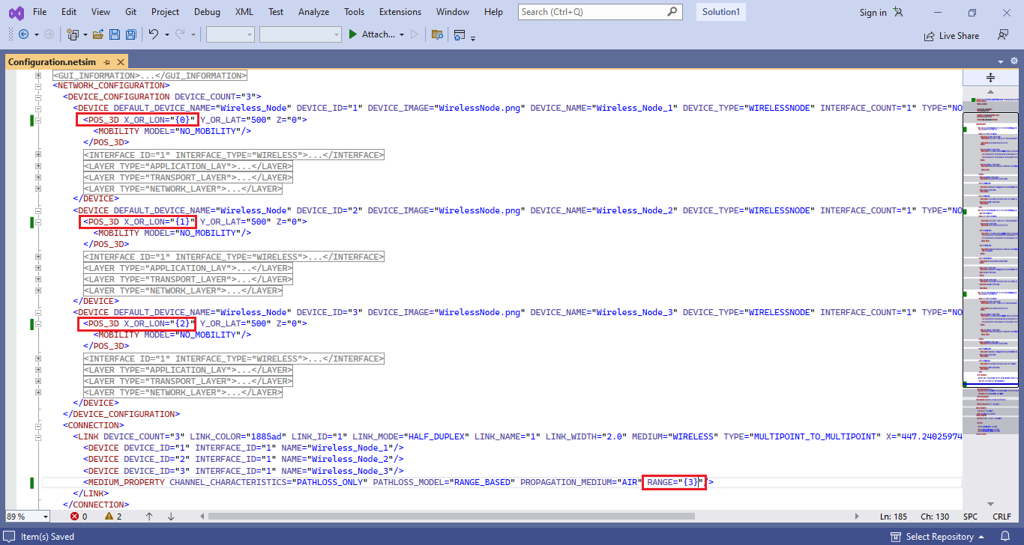

1. Save the configuration file and rename it as input.xml.
2. Download the multi-parameter sweeper from the given link and paste input.xml, all the static route text files in that folder.
3. Open the multi-parameter-sweeper.m file in MATLAB and run.
4. The multi-parameter sweeper will conduct simulations for various distances across each path loss range.

## MATLAB code for obtaining from the analytical expression

We recall that the theoretical formula for probability of network connectivity for nodes is

where is the unit step function i.e., when and when . The MATLAB code for this is provided below.

function analytical_probability(n)

analytical_prob = zeros(1,20);

j=1;

for r_z = 0.05:0.05:1

pro=0;

for k=0:n-1

pro = pro + nchoosek(n-1,k)*(power(-1,k))*(power(1-k*r_z,n))*

unit_func(1-k*r_z);

end

analytical_prob(1,j)=pro;

j=j+1;

end

disp(analytical_prob)

end

function out = unit_func(z)

if z>0

out =1;

else

out = 0;

end

end

## Results

|  |  |  |  |  |  |  |  |  |
| --- | --- | --- | --- | --- | --- | --- | --- | --- |
| **Normalized transmission range** | **Network Connectivity Fraction (N=2)** | | **Network Connectivity Fraction (N=5)** | | **Network Connectivity Fraction (N=10)** | | **Network Connectivity Fraction (N=20)** | |
|  | Sim. | Analysis | Sim. | Analysis | Sim. | Analysis | Sim. | Analysis |
| 0.05 | 0.08 | 0.097 | 0.00 | 0.001 | 0.00 | 0.000 | 0.00 | 0.000 |
| 0.10 | 0.15 | 0.190 | 0.01 | 0.010 | 0.00 | 0.002 | 0.05 | 0.019 |
| 0.15 | 0.25 | 0.277 | 0.05 | 0.043 | 0.04 | 0.045 | 0.47 | 0.393 |
| 0.20 | 0.35 | 0.360 | 0.13 | 0.115 | 0.19 | 0.243 | 0.84 | 0.787 |
| 0.25 | 0.47 | 0.437 | 0.23 | 0.234 | 0.57 | 0.528 | 0.95 | 0.939 |
| 0.30 | 0.56 | 0.510 | 0.38 | 0.389 | 0.75 | 0.750 | 1.00 | 0.984 |
| 0.35 | 0.62 | 0.577 | 0.55 | 0.550 | 0.88 | 0.879 | 1.00 | 0.996 |
| 0.40 | 0.65 | 0.640 | 0.70 | 0.691 | 0.95 | 0.946 | 1.00 | 0.999 |
| 0.45 | 0.69 | 0.697 | 0.77 | 0.799 | 0.99 | 0.977 | 1.00 | 0.999 |
| 0.50 | 0.73 | 0.750 | 0.86 | 0.875 | 1.00 | 0.991 | 1.00 | 1.00 |
| 0.55 | 0.75 | 0.797 | 0.95 | 0.926 | 1.00 | 0.997 | 1.00 | 1.00 |
| 0.60 | 0.79 | 0.840 | 0.99 | 0.959 | 1.00 | 0.999 | 1.00 | 1.00 |
| 0.65 | 0.84 | 0.877 | 0.99 | 0.979 | 1.00 | 1.00 | 1.00 | 1.00 |
| 0.70 | 0.89 | 0.910 | 0.99 | 0.990 | 1.00 | 1.00 | 1.00 | 1.00 |
| 0.75 | 0.92 | 0.937 | 0.99 | 0.996 | 1.00 | 1.00 | 1.00 | 1.00 |
| 0.80 | 0.93 | 0.960 | 1.00 | 0.999 | 1.00 | 1.00 | 1.00 | 1.00 |
| 0.85 | 0.96 | 0.977 | 1.00 | 1.00 | 1.00 | 1.00 | 1.00 | 1.00 |
| 0.90 | 0.98 | 0.990 | 1.00 | 1.00 | 1.00 | 1.00 | 1.00 | 1.00 |
| 0.95 | 1.00 | 0.997 | 1.00 | 1.00 | 1.00 | 1.00 | 1.00 | 1.00 |
| 1.00 | 1.00 | 1.000 | 1.00 | 1.00 | 1.00 | 1.00 | 1.00 | 1.00 |

Table 2: Results of NetSim simulation and analysis for N= 2, 5, 10 and 20 nodes. The network connectivity fraction is the ratio of number of times the network is connected to the total number of simulation runs.

Figure 3: Plot comparing simulation results against analytical model for probability of network connectivity for different transmission ranges.

## Exercises

1. Configure NetSim simulations for node counts such as 3, 4, 6, 7, 8 etc. Then tabulate the output results containing Network connectivity for various Normalized Transmission Ranges using NetSim simulation, and from the closed form expression provided. Plot the results and compare simulation results vs. theory.

# References

|  |  |
| --- | --- |
| [1] | A. Kumar, D. Manjunath and J. Kuri, Wireless Networking, Morgan Kaufmann, 2008. |

1. This experiment is based on Section 9.2 of [1].